1. FINAL CAPSTONE-PROJECT

GitHub Link -https://github.com/Vengat003/capstone-project.git

Jenkins console output <https://drive.google.com/file/d/1R7WbNx4C_HAZ4U6Q8gcWnHZJE9rGMavK/view?usp=sharing>

Docker images name – capstone-image

Create The First Instances For Capstone-Project

Security Group For Instance 1

Launch The First Instances Using Mobaxterm

Creating A Shell File To Install The Necessary Packages

To Change The Permission For Executing The Service.sh file

Docker Status

To Check The status For Java And Jenkins

To Clone Git Repo With Your Local Machine

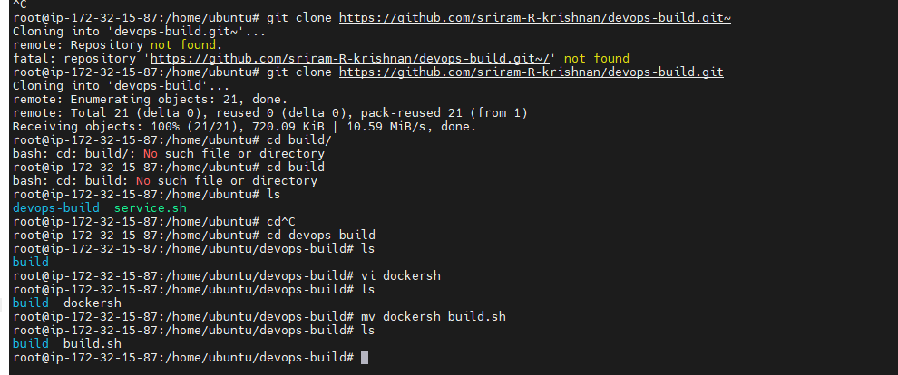

Docker File Was Created

Build The Docker Image

Checking Whether The Image is Created

Docker Compose File Created For The Capstone-Image

Docker File Output From Instance 1

Push the Code To Github To Dev Branch

After All Codes Pushing To Github To Dev Branch

Create Two Repos Dev (Public)And Prod(Private) For Pushing Images

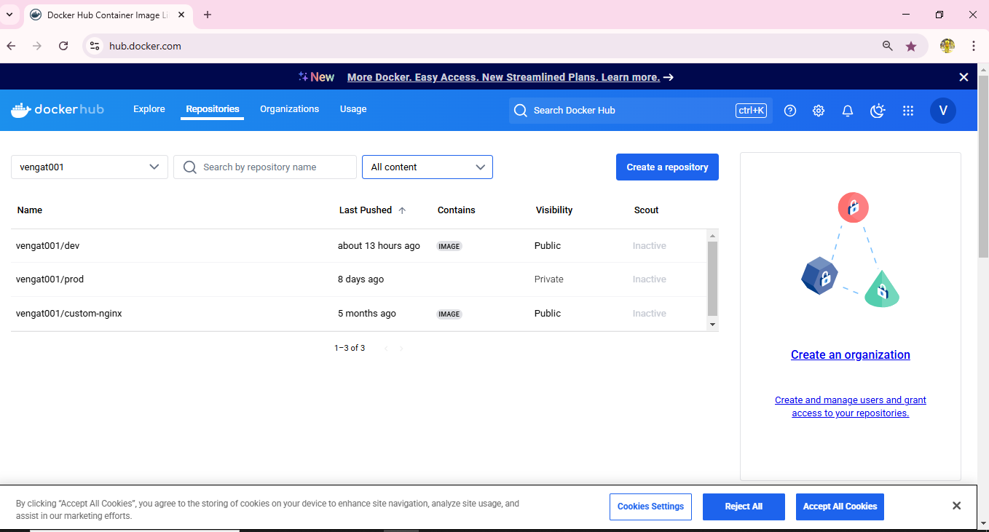

Login To Jenkins

Create New Pipeline For Capstone-project

Connect Jenkins To The Github Repo With Auto Build Trigger From Both Dev & Main Branch

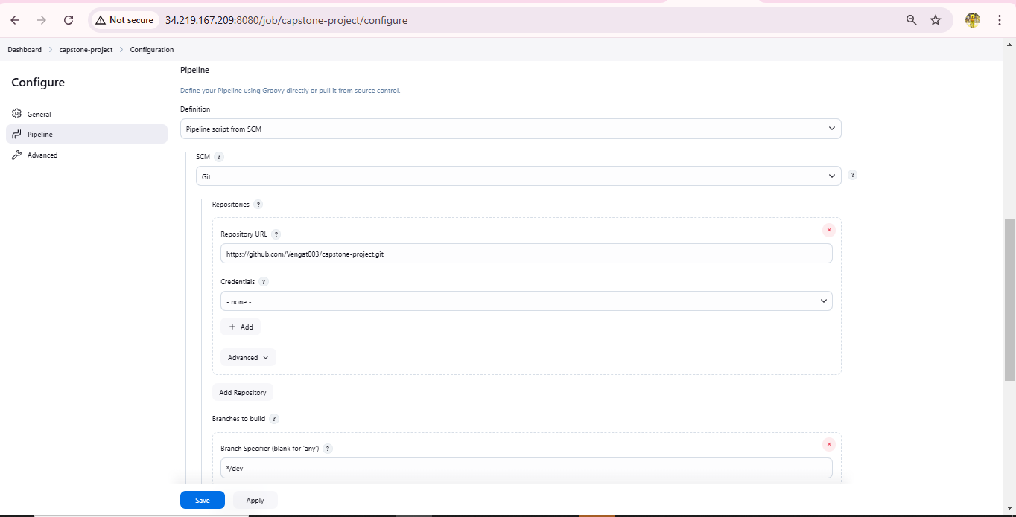

Jenkins Variables Config

Capstone-Project Build Run Success In Jenkins

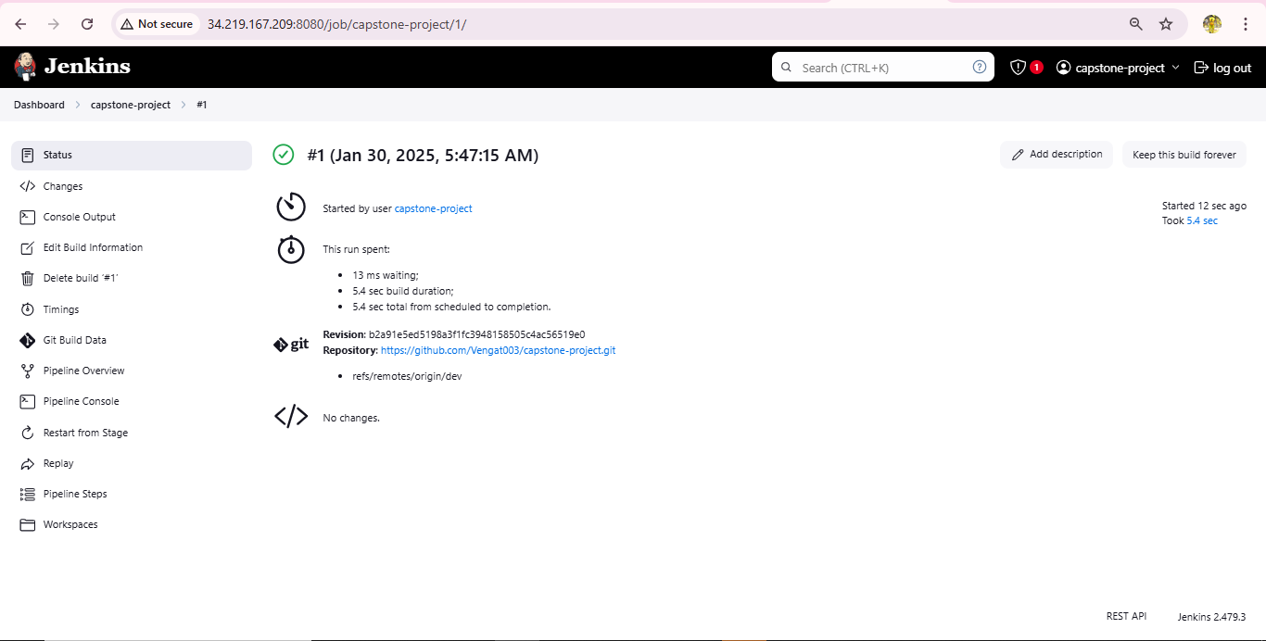

Pushed Code To Dockerhub To dev repo With Tag

Security Group For Instance 2

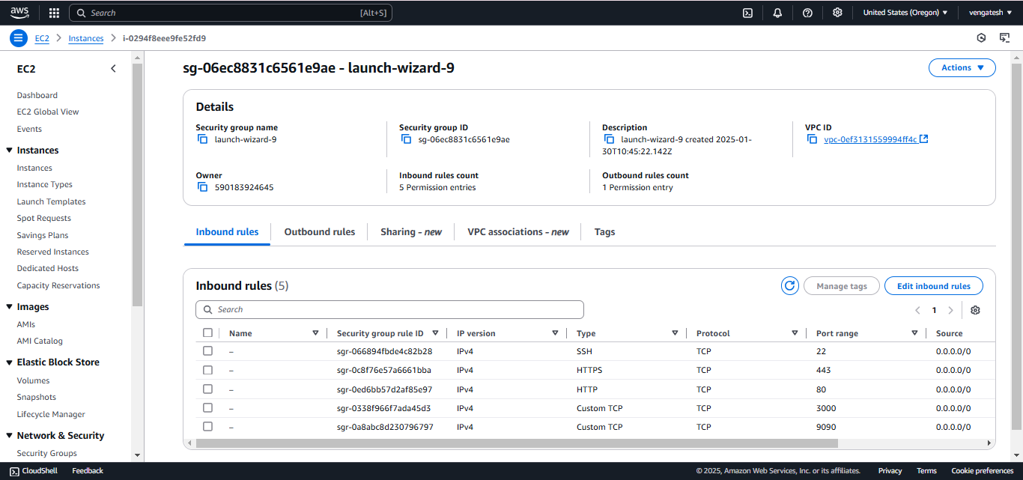

Enabled And Start And Check The Status For Docker

Docker Login In Instance 2

Pull The Docker Image To Instance 2

Run The Docker Image in Instances 2

Docker Image Output In Instances 2

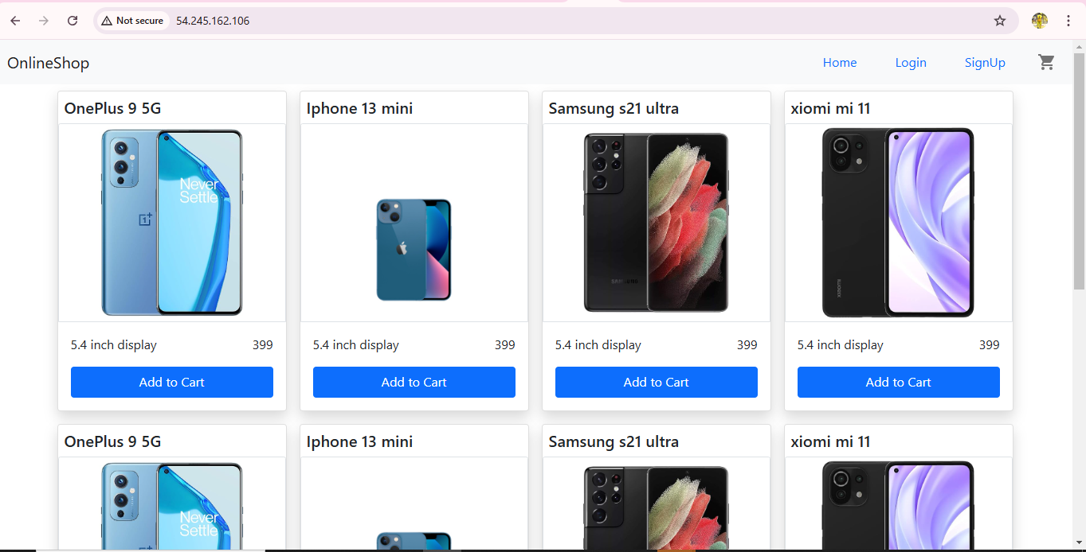

Install Prometheus and grafana For Monitoring

Vi Prometheus.sh

Install Prometheus In Instance 2

Prometheus Version

Prometheus Dashboard

Vi Grafana.sh

Install Grafana In Instances 2

Grafana Dashboard

Prometheus Is Data Source For Grafana

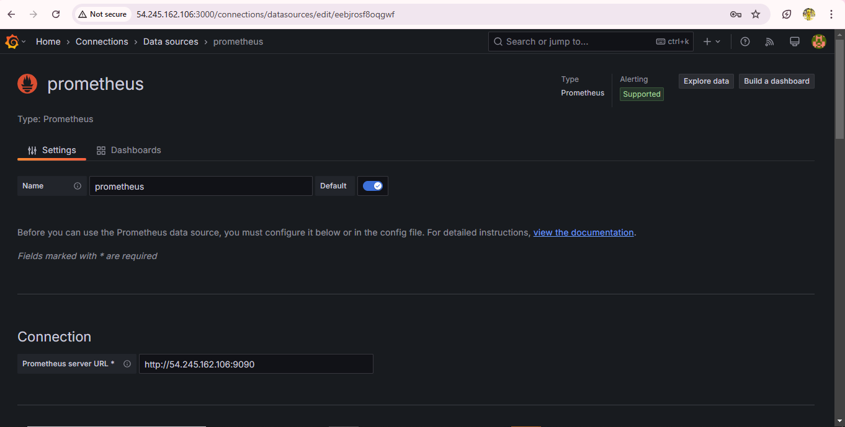

Grafana Saved Dashboard

Final Output For Capstone-Project

